Nicholas Lichtsinn

Lab 9

6/4/2021

Part 1 - Securing Data Objects

1. Create GuestUser

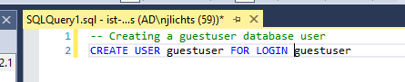

1. All rows from user login table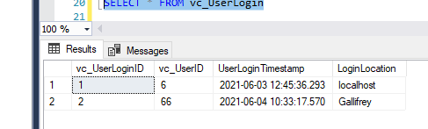
2. vc_VidCast record that was modified by guest user

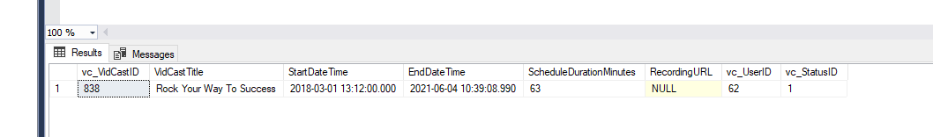

**GuestUser Code:**

SELECT * FROM vc_User

SELECT * FROM vc_MostProlificUsers

EXEC vc_AddUserLogin 'TheDoctor', 'Gallifrey'

EXEC vc_FinishVidCast '838'

**My Code:**

-- Creating a guestuser database user

CREATE USER guestuser FOR LOGIN guestuser

-- Grant read permission on the user table

GRANT SELECT ON vc_User TO guestuser

-- Revoke select permission

REVOKE SELECT ON vc_User to guestuser

-- Grant view permission

GRANT SELECT ON vc_MostProlificUsers to guestuser

-- allow guestuser to run some stored procedures

GRANT EXECUTE ON vc_AddUserLogin TO guestuser

GRANT EXECUTE ON vc_FinishVidCast TO guestuser

SELECT vc_VidCastID FROM vc_VidCast WHERE VidCastTitle = 'Rock Your Way To Success'

SELECT * FROM vc_UserLogin

SELECT * FROM vc_VidCast WHERE VidCastTitle = 'Rock Your Way To Success'

Part 2 - Data Integrity Through Transactions

1. Transaction
2. The reason the first attempt failed was because we tried to insert a value into the table that was already there and we made the column ‘unique’ so entering in that value didn’t work with the parameters of our database so the transaction failed. In the second attempt the value ‘Lichtsinn’ was not already present so it worked.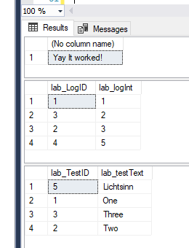
3. I did not expect the lab_testID for the second attempt to be 5 but I guess that is because it added a surrogate ID for the first attempt as well before it failed?

SQL Code:

-- Part 2

CREATE TABLE lab_Test (

lab_TestID int identity primary key

, lab_testText varchar(20) unique not null

)

CREATE TABLE lab_Log (

lab_LogID int identity primary key

, lab_logInt int unique not null

)

INSERT INTO lab_Test (lab_testText) VALUES ('One'), ('Two'), ('Three')

INSERT INTO lab_Log (lab_logInt) SELECT lab_TestID FROM lab_Test

-- step1 begin transaction

BEGIN TRANSACTION

DECLARE @rc int

SET @rc = @@ROWCOUNT

INSERT INTO lab_Test (lab_testText) VALUES ('Lichtsinn')

IF(@rc = @@ROWCOUNT)

BEGIN

SELECT 'Bail out! It Failed!'

ROLLBACK

END

ELSE

BEGIN

SELECT 'Yay It worked!'

INSERT INTO lab_Log (lab_logInt) VALUES (SCOPE_IDENTITY())

COMMIT

END

SELECT * FROM lab_Log

SELECT * FROM lab_Test